**DAYANANDA SAGAR UNIVERSITY**



**MOBILE PROGRAMMING**

Mini Project

Report on

<BUDGET MANAGER APP>

SUBMITTED BY

|  |  |  |
| --- | --- | --- |
| **USN Number** | **Name** | **Sign** |
| ENG20CA0005 | AVANTIKA |  |
| ENG20CA0023 | NANDINI GARG |  |
| ENG20CA0026 | PRATIK RAJ |  |
| ENG20CA0042 | SHREYA JAISWAL |  |

Under the Guidance of

Prof. Pavithra.K

**Department of COMPUTER Applications**

SCHOOL OF ENGINEERING

DAYANANDA SAGAR UNIVERSITY

KUDLU GATE

BANGALORE -560068

**DAYANANDA SAGAR UNIVERSITY**

SCHOOL OF ENGINEERING

DAYANANDA SAGAR UNIVERSITY

KUDLU GATE

BANGALORE -560068



**CERTIFICATE**

This is to certify that students in team of 4 consisting [Avantika-ENG20CA0005, Nandini Garg-ENG20CA0023, Pratik Raj-ENG20CA0026, Shreya Jaiswal-ENG20CA0042] of 4th Semester BCA have successfully completed this mini project for the course of MOBILE PROGRAMMING **(21CA3504)** as the partial fulfillment of Internal Assessment for the academic year 2022-2023.

|  |  |  |
| --- | --- | --- |
| **USN** | **Name** | **Marks Awarded** |
| ENG20CA0005 | AVANTIKA |  |
| ENG20CA0023 | NANDINI GARG |  |
| ENG20CA0026 | PRATIK RAJ |  |
| ENG20CA0042 | SHREYA JAISWAL |  |

Faculty– In charge

Prof. Pavithra K

Professor

Dept. Of BCA

School of Engineering

Dayananda Sagar University

**ABSTRACT**

Personal Budgeting app is an android application. This monitors your own costs, family costs and incidental costs. This resembles a present day costs book in your versatile.This application helps you to monitor your everyday costs, settlement points of interest, general rundown, report in detail and periodic costs subtle elements. Every one of the information is put away in database and can be recovered by the client and their relatives

**TABLE OF CONTENT**

**CHAPTER TOPICS PAGE NO.**

CERTIFICATE

ABSTRACT

TABLE OF CONTENT

LIST OF FIGURES

LIST OF TABLES

1. INTRODUCTION

2. PROBLEM STATEMENT

3. SYNOPSIS AND DEVELOPMENT

4. APPENDIX A (CODIING)

5. APPENDIX B (OUTPUT)

**CHAPTER 1: INTRODUCTION**

In this chapter, we briefly describe the major areas and the framework we have used to implement this Budget Manager App.

### **What is a Budget Manager App?**

This app is a budget manager application. This app will help user to keep track of their expenses. Getting your finances in order begins with tracking your spending and considering your budget. You can reduce your expenses by understanding what you spend money on and how much you spend.

### **Flow of the Budget Manager App in Android**

There is a dashboard screen. The dashboard screen will show the user their budget and their expenses. There is an add button on the screen that allows users to add expenses and their budget or income. The budget button is to add what you have earned. The expense button is to add what you have spent.

There is a budget tab. This tab shows users all their budgets for particular items. In this tab, users can update their budget and even add categories and a note with it.

There is an expense tab. This tab shows users all their expenses. In this tab, users can update their expenses and add categories and a note.

### Features of Budget Manager App

1. There are three tabs on the main screen.

2. The dashboard screen shows all their spending and income.

3. The add button allows users to add new budget or spending.

4. They can even add categories and even a note with it.

5. The budget tab shows all the income of the users and updates it.

6. They can also see the graph of their budget maintained. This graph is a pie chart that shows all category-wise budget to the user.

7. The expense tab shows all the expenses of the users. You can also update it.

8. They can also see the graph of their expenses. This graph is a pie chart which shows all category-wise spending to the user.

**CHAPTER 2: PROBLEM STATEMENT**

**Problem:**

1. Unplanned expenditure
2. Lack of consolidated view of monthly budget
3. Non-transparency for an individual saving
4. Hinder vision for future investment
5. Missing information about emergency funds

**Solution:**

To develop a budget app which provides the following components:

1. It makes sure that you're using all of your money well. This is helpful for learning to make fewer impulsive purchases.

2. It allows you to budget accordingly so that you have the money you need to pay for all of your expenses

3. It makes it easier for you to recover after making a mistake. If you overspend, it will be okay -- because you've got extra money budgeted elsewhere. You can move already allocated money around to make it work.

4. It allows you to get ahead and not live paycheck to paycheck anymore. After some time of using You Need a Budget, you'll have a routine in place and you'll always be ahead.

**CHAPTER 3: SYNOPSIS AND DEVELOPMENT**

**Synopsis**

You will be able to understand Android Studio’s workings if you are familiar with them. The following technologies/tools are required for the project.

* Java – The logic of the application will be written in Java.
* XML – The designing portion of our application will be coded in XML.
* Android Studio – We will be using android studio to create the apps.
* SQLite – You should be familiar with SQLite. This will be used as a database.

### **Development of the project**

### Let’s look at the files that we created for the Budget Manager app before we implement it. Let us see them one by one-

### 1. Activity_dashboard.xml is the file that will contain all the design codes of our dashboard activity.

### 2. The next file is the dashboard.java activity where we will be writing all the logic of our application.

3. The next file is budget.xml and expense.xml which will contain all the design codes of our income and expense activity.

4. The next file is budget.java and expense.java which we will be writing all the logic of our application.

5. We will also create a database Handler.java which will handle all the database activities.

**CHAPTER 4: APPENDIX A (CODING)**

**MainActivity.java**

package com.example.expensetrackersystem;

import android.os.Bundle;

import android.view.MenuItem;

import android.view.View;

import android.widget.Toast;

import androidx.annotation.NonNull;

import androidx.appcompat.app.AppCompatActivity;

import com.example.expensetrackersystem.fragments.Dashboard;

import com.example.expensetrackersystem.fragments.Expense;

import com.example.expensetrackersystem.fragments.Income;

import com.google.android.material.bottomnavigation.BottomNavigationView;

Public class MainActivity extends AppCompatActivity implements BottomNavigationView.OnNavigationItemSelectedListener {

BottomNavigationView bottomNavigationView;

@Override

protected void onCreate(Bundle savedInstanceState) {

super.onCreate(savedInstanceState);

setContentView(R.layout.**activity_main**);

bottomNavigationView = findViewById(R.id.**bottomNavigationView**);

bottomNavigationView.setOnNavigationItemSelectedListener(this);

bottomNavigationView.setSelectedItemId(R.id.**dashboard**);

}

Dashboard dashboardFragment = new Dashboard();

Expense expenseFragment = new Expense();Income incomeFragment = new Income();

@Override

public boolean onNavigationItemSelected(@NonNull MenuItem item) {

switch (item.getItemId()) {

case R.id.**income**:

getSupportFragmentManager().beginTransaction().replace(R.id.**flFragment**, incomeFragment).commit();return true;

case R.id.**dashboard**:

getSupportFragmentManager().beginTransaction().replace(R.id.**flFragment**, dashboardFragment).commit();return true;

case R.id.**expense**:

getSupportFragmentManager().beginTransaction().replace(R.id.**flFragment**, expenseFragment).commit();return true;}

return false;}}

**DatabaseHandler.java**

package com.example.expensetrackersystem;

import android.content.ContentValues;

import android.content.Context;

import android.database.Cursor;

import android.database.sqlite.SQLiteDatabase;

import android.database.sqlite.SQLiteOpenHelper;

import androidx.annotation.Nullable;

import com.example.expensetrackersystem.model.incomeModel;

import java.util.ArrayList;

import java.util.List;

public class DatabaseHandler extends SQLiteOpenHelper {

public static final String **DATABASE_NAME** = "income.db";

public static final String **TABLE_NAME** = "income_data";

public static final String **COL1** = "ID";

public static final String **COL2** = "AMOUNT";

public static final String **COL3** = "TYPE";

public static final String **COL4** = "NOTE";

public static final String **COL5** = "DATE";

public DatabaseHandler(@Nullable Context context) {

super(context, **DATABASE_NAME**, null, 1);}

@Override

public void onCreate(SQLiteDatabase db) {

String createTable = "CREATE TABLE " + **TABLE_NAME** + "(ID INTEGER PRIMARY KEY AUTOINCREMENT," + "AMOUNT TEXT," + "TYPE TEXT," + "NOTE TEXT," + "DATE TEXT)";

db.execSQL(createTable);}

@Override

public void onUpgrade(SQLiteDatabase db, int oldVersion, int newVersion) {

String a = "DROP TABLE IF EXISTS " + **TABLE_NAME**;db.execSQL(a);onCreate(db);}

public boolean addData(String amount, String type, String note, String date) {

SQLiteDatabase db = this.getWritableDatabase();

ContentValues contentValues = new ContentValues();

contentValues.put(**COL2**, amount);

contentValues.put(**COL3**, type);

contentValues.put(**COL4**, note);

contentValues.put(**COL5**, date);

long result = db.insert(**TABLE_NAME**, null, contentValues);

if (result == -1) {return false;} else {return true; }}

public void update(String id, String amount, String type, String note, String date) {

SQLiteDatabase database = this.getWritableDatabase();

ContentValues contentValues = new ContentValues();

contentValues.put(**COL2**, amount);

contentValues.put(**COL3**, type);

contentValues.put(**COL4**, note);

contentValues.put(**COL5**, date);

long result = database.update(**TABLE_NAME**, contentValues, "id=?", new String[]{id});

if (result == -1) {} else {}}

public List<incomeModel> getAllIncome() {

List<incomeModel> incomeModelList = new ArrayList<>();

SQLiteDatabase db = this.getWritableDatabase();

Cursor data = db.rawQuery("SELECT * FROM " + **TABLE_NAME**, null);

if (data.getCount() == 0) {} else {if (incomeModelList == null) {incomeModelList = new ArrayList<>(); }

while (data.moveToNext()) {incomeModelList.add(new incomeModel(data.getString(0), data.getString(1), data.getString(2), data.getString(3), data.getString(4)));}}

return incomeModelList;}}

**Piechart.java**

*package* com.example.expensetrackersystem;

*import* android.graphics.Color;

*import* android.os.Bundle;

*import* androidx.appcompat.app.AppCompatActivity;

*import* com.example.expensetrackersystem.model.expenseModel;

*import* java.util.ArrayList;

*import* java.util.HashMap;

*import* java.util.*List*;

*import* lecho.lib.hellocharts.model.PieChartData;

*import* lecho.lib.hellocharts.model.SliceValue;

*import* lecho.lib.hellocharts.view.PieChartView;

*public class* PieChart *extends* AppCompatActivity {

*private List*<String> xData = *new* ArrayList<>();

ArrayList pieEntries;

*private* DatabaseHandlerExpense databaseHandlerExpense;

HashMap<String, String> map;

PieChartView pieChartView;

*List*<SliceValue> pieData;

@Override

*protected void* onCreate(Bundle savedInstanceState) {

*super*.onCreate(savedInstanceState);

setContentView(R.layout.***activity_pie_chart***);

pieChartView = findViewById(R.id.***chart***);

databaseHandlerExpense = *new* DatabaseHandlerExpense(PieChart.*this*);

addData();

getEntries();

PieChartData pieChartData = *new* PieChartData(pieData);

pieChartData.setHasLabels(*true*).setValueLabelTextSize(14);

pieChartData.setHasCenterCircle(*true*).setCenterText1("Expenses").setCenterText1FontSize(20).setCenterText1Color(Color.*parseColor*("#0097A7"));pieChartView.setPieChartData(pieChartData);}

*private void* addData() {

*List*<expenseModel> expenseModelList = databaseHandlerExpense.getAllIncome();

*for* (expenseModel model : expenseModelList) {xData.add(model.getType());}

map = *new* HashMap<>();

*for* (expenseModel model : expenseModelList) {

*int* amount = Integer.*parseInt*(model.getAmount());

*if* (map.containsKey(model.getType())) {

*int* a = Integer.*parseInt*(map.get(model.getType()));

map.put(model.getType(), String.*valueOf*(a + amount));} *else* {

map.put(model.getType(), model.getAmount());}}}

*private void* getEntries() {

pieEntries = *new* ArrayList<>();

*int* i = 0;

pieData = *new* ArrayList<>();

ArrayList<Integer> colors = *new* ArrayList<Integer>();

colors.add(Color.***MAGENTA***);colors.add(Color.***BLUE***);colors.add(Color.***YELLOW***);colors.add(Color.***RED***);colors.add(Color.***GREEN***);

*for* (String type : xData) {pieData.add(*new* SliceValue(Float.*parseFloat*(map.get(type)), colors.get(i % 5)).setLabel(type));i++;}}}

**Activity Mainfest.xml**

<?xml version="1.0" encoding="utf-8"?>

<manifest xmlns:android="http://schemas.android.com/apk/res/android"

package="com.example.expensetrackersystem">

<application android:allowBackup="true"android:icon="@mipmap/ic_launcher"android:label="@string/app_name" android:roundIcon="@mipmap/ic_launcher_round" android:supportsRtl="true"

[android:theme="@style/Theme.ExpenseTrackerSystem](mailto:android:theme=%22@style/Theme.ExpenseTrackerSystem)">

<activity android:name=".PieChartBudget"android:exported="true" />

<activity android:name=".PieChart" android:exported="true" />

<activity android:name=".MainActivity" android:exported="true">

<intent-filter>

<action android:name="android.intent.action.MAIN" />

<category android:name="android.intent.category.LAUNCHER" />

</intent-filter>

</activity>

<meta-data android:name="preloaded_fonts" android:resource="@array/preloaded_fonts" />

</application>

</manifest>

**Activity_main.xml**

<?xml version="1.0" encoding="utf-8"?>

<RelativeLayout xmlns:android="http://schemas.android.com/apk/res/android"

xmlns:app="http://schemas.android.com/apk/res-auto"

xmlns:tools="http://schemas.android.com/tools"

android:layout_width="match_parent"

android:layout_height="match_parent"

android:orientation="vertical"

tools:context=".MainActivity">

<FrameLayout

android:id="@+id/flFragment"

android:layout_width="match_parent"

android:layout_height="match_parent"

android:layout_above="@id/bottomNavigationView"

app:layout_constraintBottom_toTopOf="@+id/bottomNavigationView"

app:layout_constraintEnd_toEndOf="parent"

app:layout_constraintHorizontal_bias="0.5"

app:layout_constraintStart_toStartOf="parent"

app:layout_constraintTop_toTopOf="parent" />

<com.google.android.material.bottomnavigation.BottomNavigationView

android:id="@+id/bottomNavigationView"

android:layout_width="match_parent"

android:layout_height="wrap_content"

android:layout_alignParentBottom="true"

android:layout_marginStart="0dp"

android:layout_marginEnd="0dp"

android:elevation="3dp"

android:fitsSystemWindows="true"

app:itemBackground="@color/black"

app:itemIconTint="@drawable/tab_color"

app:itemTextColor="@drawable/tab_color"

app:menu="@menu/menu" />

**Menu.xml**

<?xml version="1.0" encoding="utf-8"?>

<menu xmlns:android="http://schemas.android.com/apk/res/android">

<item

android:id="@+id/income"

android:icon="@drawable/add"

android:title="Budget" />

<item

android:id="@+id/dashboard"

android:icon="@drawable/menu"

android:title="Dashboard" />

<item

android:id="@+id/expense"

android:icon="@drawable/minus"

android:title="Expense" />

</menu>

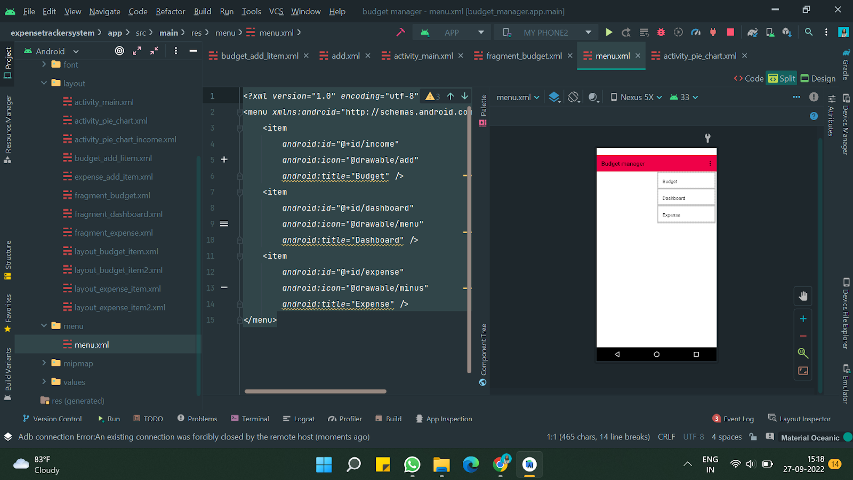

**Budget_additem.xml**

<?xml version="1.0" encoding="utf-8"?>

<LinearLayout xmlns:android="http://schemas.android.com/apk/res/android"

android:layout_width="match_parent"

android:layout_height="wrap_content"

android:orientation="vertical"

android:padding="10dp">

<LinearLayout

android:layout_width="match_parent"

android:layout_height="wrap_content"

android:layout_margin="8dp"

android:orientation="horizontal"

android:weightSum="5">

<TextView

android:layout_width="0dp"

android:layout_height="wrap_content"

android:layout_marginLeft="8dp"

android:layout_weight="2"

android:text="Amount: "

android:textColor="@color/textColor"

android:textSize="20sp" />

<EditText

android:id="@+id/et_incomeAmount"

android:layout_width="0dp"

android:layout_height="wrap_content"

android:layout_marginLeft="8dp"

android:layout_marginRight="8dp"

android:layout_weight="3"

android:hint="Enter amount"

android:inputType="number"

android:textColor="@color/textColor"

android:textSize="20sp" />

</LinearLayout>

<LinearLayout

android:layout_width="match_parent"

android:layout_height="wrap_content"

android:layout_margin="8dp"

android:orientation="horizontal"

android:weightSum="5">

<TextView

android:layout_width="0dp"

android:layout_height="wrap_content"

android:layout_marginLeft="8dp"

android:layout_weight="2"

android:text="Type: "

android:textColor="@color/textColor"

android:textSize="20sp" />

<EditText

android:id="@+id/et_incomeType"

android:layout_width="0dp"

android:layout_height="wrap_content"

android:layout_marginLeft="8dp"

android:layout_marginRight="8dp"

android:layout_weight="3"

android:hint="Enter type"

android:textColor="@color/textColor"

android:textSize="20sp" />

</LinearLayout>

<LinearLayout

android:layout_width="match_parent"

android:layout_height="wrap_content"

android:layout_margin="8dp"

android:orientation="horizontal"

android:weightSum="5">

<TextView

android:layout_width="0dp"

android:layout_height="wrap_content"

android:layout_marginLeft="8dp"

android:layout_weight="2"

android:text="Note: "

android:textColor="@color/textColor"

android:textSize="20sp" />

<EditText

android:id="@+id/et_incomeNote"

android:layout_width="0dp"

android:layout_height="wrap_content"

android:layout_marginLeft="8dp"

android:layout_marginRight="8dp"

android:layout_weight="3"

android:hint="Give note"

android:textColor="@color/textColor"

android:textSize="20sp" />

</LinearLayout>

<LinearLayout

android:layout_width="match_parent"

android:layout_height="wrap_content"

android:layout_margin="8dp"

android:orientation="horizontal">

<Button

android:id="@+id/btn_cancel"

android:layout_width="0dp"

android:layout_height="wrap_content"

android:layout_gravity="bottom"

android:layout_marginLeft="8dp"

android:layout_marginRight="16dp"

android:layout_weight="1"

android:background="@drawable/bg_rounded_input_field"

android:text="Cancel"

android:textAllCaps="false"

android:textColor="@color/white"

android:textSize="16sp" />

<Button

android:id="@+id/btn_save"

android:layout_width="0dp"

android:layout_height="wrap_content"

android:layout_gravity="bottom"

android:layout_marginLeft="16dp"

android:layout_marginRight="8dp"

android:layout_weight="1"

android:background="@drawable/bg_rounded_input_field"

android:text="Save"

android:textAllCaps="false"

android:textColor="@color/white"

android:textSize="16sp" />

</LinearLayout>

</LinearLayout>

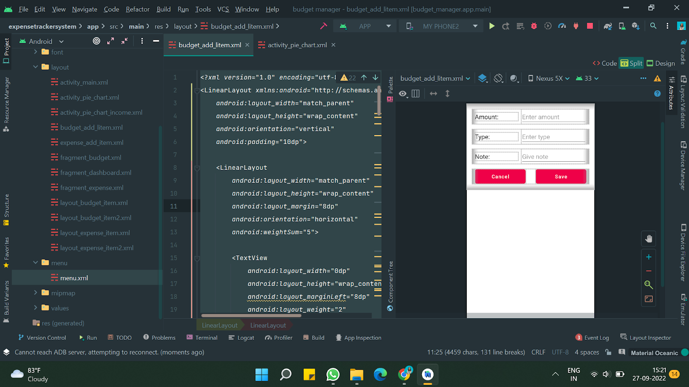

**Fragment_expense.xml**

<?xml version="1.0" encoding="utf-8"?>

<RelativeLayout xmlns:android="http://schemas.android.com/apk/res/android"

xmlns:app="http://schemas.android.com/apk/res-auto"

xmlns:tools="http://schemas.android.com/tools"

android:layout_width="match_parent"

android:layout_height="match_parent"

android:background="@color/black"

tools:context=".fragments.Expense">

<TextView

android:id="@+id/tv_text"

android:layout_width="wrap_content"

android:layout_height="wrap_content"

android:layout_marginLeft="30dp"

android:layout_marginTop="20dp"

android:text="BudgetManager"

android:textColor="@color/white"

android:textSize="32sp" />

<TextView

android:id="@+id/tv_text2"

android:layout_width="wrap_content"

android:layout_height="wrap_content"

android:layout_below="@id/tv_text"

android:layout_marginLeft="30dp"

android:layout_marginTop="15dp"

android:layout_marginBottom="20dp"

android:text="Expense"

android:textColor="@color/white"

android:textSize="28sp" />

<RelativeLayout

android:id="@+id/rr"

android:layout_width="match_parent"

android:layout_height="wrap_content"

android:layout_below="@id/tv_text2">

<LinearLayout

android:id="@+id/ll"

android:layout_width="wrap_content"

android:layout_height="wrap_content"

android:layout_centerHorizontal="true"

android:gravity="center"

android:orientation="vertical">

<TextView

android:layout_width="wrap_content"

android:layout_height="wrap_content"

android:fontFamily="@font/bungee_inline"

android:text="Expense"

android:textColor="@color/light_red"

android:textSize="24sp" />

<TextView

android:id="@+id/tvExpense"

android:layout_width="wrap_content"

android:layout_height="wrap_content"

android:text="Rs. 10000.00"

android:textColor="@color/light_red"

android:textSize="24sp" />

</LinearLayout>

<ImageView

android:id="@+id/iv_expensePie"

android:layout_width="50dp"

android:layout_height="50dp"

android:layout_alignParentEnd="true"

android:layout_centerVertical="true"

android:layout_marginRight="16dp"

android:src="@drawable/ic_baseline_pie_chart_24"

app:tint="@color/purple_200" />

</RelativeLayout>

<androidx.recyclerview.widget.RecyclerView

android:id="@+id/rvExpense"

android:layout_width="wrap_content"

android:layout_height="wrap_content"

android:layout_below="@id/rr"

android:layout_marginTop="14dp"

android:scrollbars="horizontal"

tools:listitem="@layout/layout_expense_item2" />

</RelativeLayout>

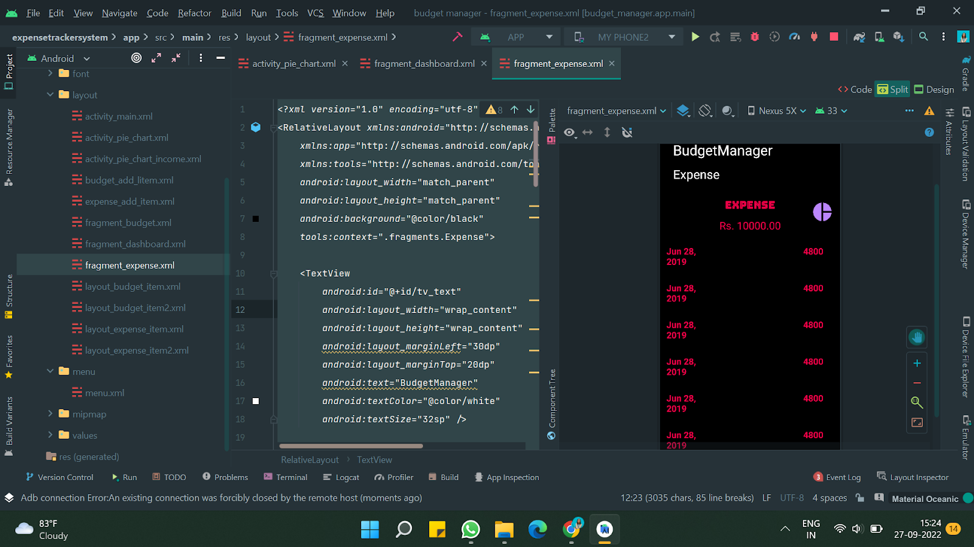

**OUTPUT**

**Drawable folder**

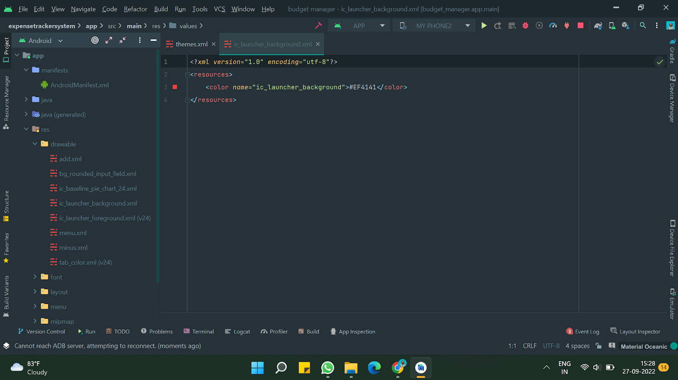

**Layout folder**

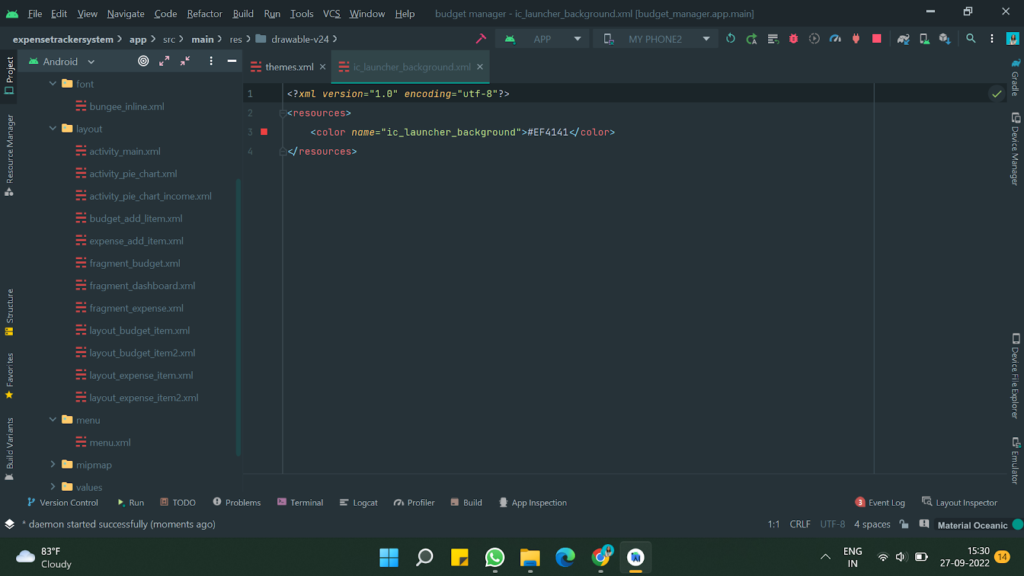

**Java folder**

